Case 19- AM,C-Taino-Pendant-Anthropomorph-Seated-Manatee Bone-1000-1500 CE

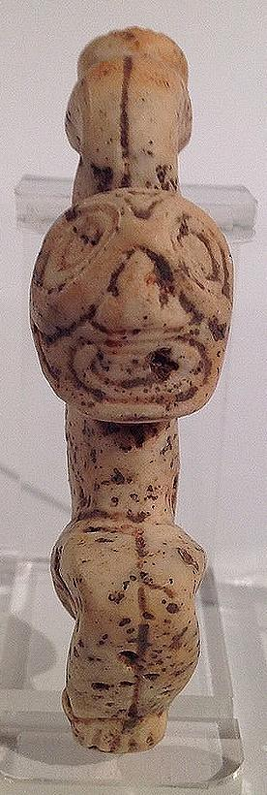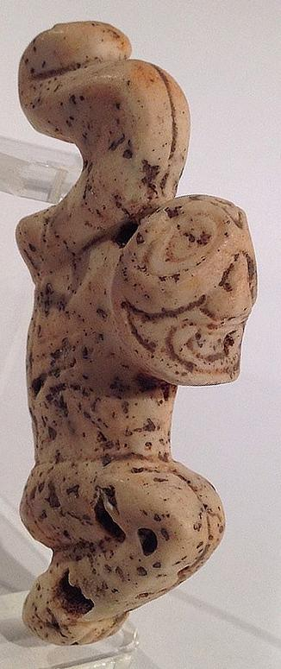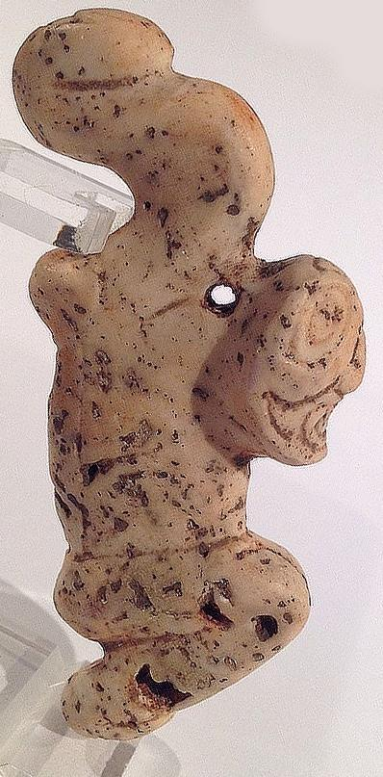
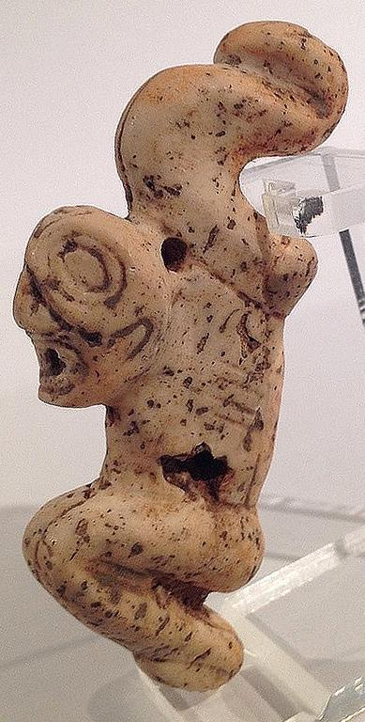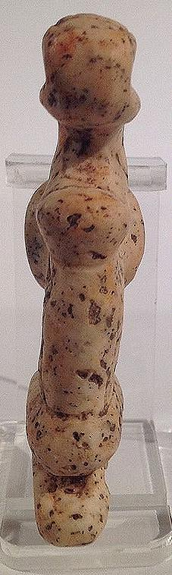
Figs. 1-5. AM,C-Taino-Pendant-Anthropomorph-Seated-Manatee Bone-1000-1500 CE
Case No.: 19
Accession Number:
Formal Label: AM,C-Taino-Pendant-Anthropomorph-Seated-Manatee Bone-1000-1500 CE
Display Description:
This contorted figure must have originated in a hallucinogenic trance. Hands curve back over head with knees tightly drawn. It is made from fossil coral. The hole seen on the side of pendant figure 4 is a natural imperfection. It measures 8.5cm or 3.3". Originally from the Dominican Republic. LC Classification:
Date or Time Horizon: 1000-1500 CE
Geographical Area: Caribbean
Map:
GPS Coordinates:
Cultural Affiliation: Taino
Medium: Manatee Bone
Dimensions:
Weight:
Provenance:
Condition:
Discussion:
References:

Order details

Sales order
Sold by flapast ( 13303 )

Delivery package 1 of 1
Estimated delivery Saturday, Jan 9, 2016
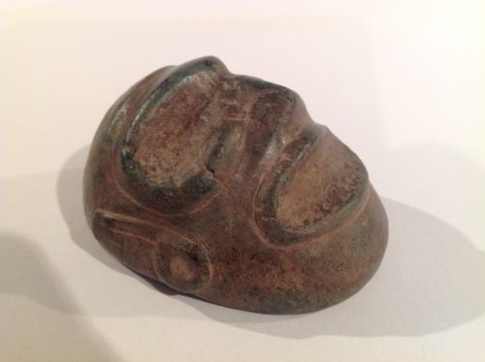

Taino Stone Ancestral Head, Pre Columbian
Item price | $162.50
Quantity | 1
Item number | 262204237732
Shipping service | USPS Priority Mail
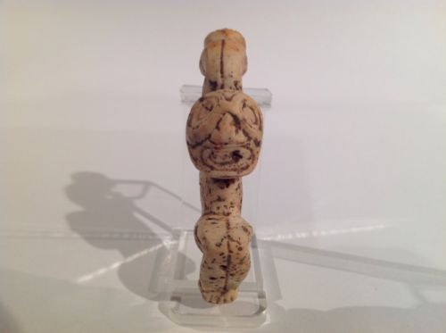

Taino Stone Spirit Being, Pre Columbian
Item price | $76.00
Quantity | 1
Item number | 262204292205
Shipping service | USPS Priority Mail

